 MediaWall® 2500
December 12, 2006

Updating firmware

Firmware updates are made available on a regular basis for download on RGB Spectrum’s web site.
The following steps must be followed in order to update the MediaWall 2500 unit’s firmware.

1. Download the compressed firmware file from RGB Spectrum’s web site:
Currently, the new firmware releases are posted as a compressed file in the Regional Manager Download Area of RGB Spectrum’s web site (http://www.rgb.com/en/rm.asp).
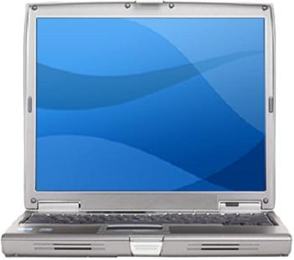
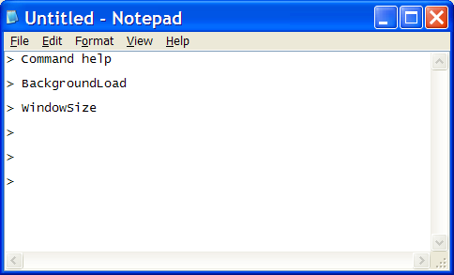
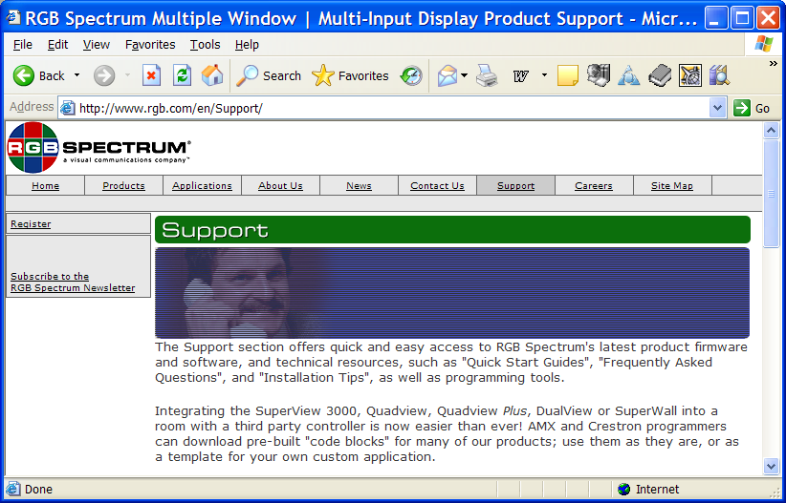
Download the file onto the computer that will be used to communicate with the MediaWall 2500.
Download the compressed firmware file from RGB’s Support web page

NOTE: DO NOT ATTEMPT TO UNCOMPRESS THE FILE ON YOUR COMPUTER.
This will be done automatically later on in the MediaWall.

2. Setup the telnet session so that it accepts commands without carriage return
On the computer connected to the MediaWall 2500, click Start, then Run, then enter telnet .
In the telnet window, type in:
> unset crlf
Close the telnet window.

3. Save your settings:
Early firmware releases used to erase presets during updates; it’s a good idea to save all of the MediaWall 2500 settings before you perform the firmware update.
3.1. Open a Telnet session:
Click Start, then Run, then enter telnet <IP Address> 8000
(Example: telnet 192.168.1.200 8000 will open a telnet session with a MediaWall 2500 with an IP address of 192.168.1.200)
3.2. Save your settings:
In the Telnet window, type in:
> settingsexport all <file_name.txt>
This will save all of the MediaWall 2500 settings into a file named “file_name.txt” in the local memory of the MediaWall 2500.
Note: Do not use special characters such as space, “/”, “\” in the file name.
(Suggestion: use a file name format like “mmddyys.txt”, where “mmddyy” is the date, and “s” a suffix of your choice)

4. Copy the settings file onto the computer and the compressed file into the MediaWall 2500:
4.1. Open an ftp session:
Open your web browser, and type ftp:<IP Address> in the address field.
(Example: ftp:192.168.1.200 will open an ftp session with a MediaWall 2500 with an IP address of 192.168.1.200)
The system will ask for a username and password:
Username: rgb
Password: spectrum
4.2. Drag the settings file (“<file_name.txt>”) from the MediaWall 2500 ftp window into a known directory on the computer.
MediaWall 2500
Save your settings

4.3. Drag the compressed firmware file from your local directory on your computer into the open MediaWall 2500 ftp window.
MediaWall 2500
Load compressed firmware file

4.4. Close the ftp browser window

5. Update the MediaWall 2500 firmware
In the telnet window opened previously (see 3.), type ufw, then type y when prompted.
The firmware will then be updated, and the connection with the MediaWall 2500 will be lost.
Power cycle the MediaWall 2500 after the connection has been lost.

6. Reload your settings
6.1. Open an ftp session:
Open your web browser, and type ftp:<IP Address> in the address field.
The system will ask for a username and password:
Username: rgb
Password: spectrum
6.2. Drag the settings file (“<file_name.txt>”) from the local directory on the computer into the MediaWall 2500.
MediaWall 2500
Reload your settings
6.3. Close the ftp browser window
6.4. Open a telnet session
Click Start, then Run, then enter telnet <IP Address> 8000
6.5. Reload your settings:
In the telnet session window, type in
> settingsimport (“<file_name.txt>

At this point the MediaWall 2500 has a new firmware and the settings (presets) that you had prior to the firmware update have been reloaded.
You may now open the WCP (Window Control Program) to operate the MediaWall 2500.

RGB Spectrum

Corporate Headquarters, USA Corporate Headquarters. Europe
950 Marina Village Parkway La Clairiere Chemin des Abeilles
Alameda, CA 94501 Quartier De Malouesse
13080 Luynes, 13080, France
Phone: 510-814-7000 Phone: +33 442 240884
Fax: 510-814-7026

